Florida Gulf Coast University
U. A. Whitaker College of Engineering

BME 3506C Circuits for Bioengineers
Fall 2025
Exam #3 (Practice)

Name

You have 75 minutes to complete this exam. The questions should not take long to answer if you know the material. I recommend that you first read all the problems so that you can think about it as you work on other problems. Do the easer ones first so that you get the majority of the exam complete early.

You are not to use any other electronic device besides your calculator.

There are some equations on the last page that you may find helpful.

Circle your answers.

Turn off your phone, laptop, I-pad, I-pod, and any other electronic device.

- (10%) Compute the sum of and and put into the form of .

- (10%) Compute the root-mean-square value of for the following wave. Use the formula as this is not a sinusoidal wave.

- (8%, 2% each) A source has across it and produces a current of .
- Compute the power factor.

- Compute the apparent power delivered by the source.

- Compute the real power delivered by the source.

- Compute the reactive power delivered by the source.

- (12%) For the following circuit with .
  - find the expression for the current.

  - Find the angular frequency, $ω$ , that results in zero reactive power.

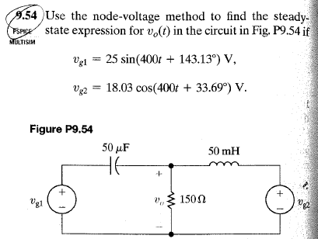

Units
1 watt = 1 joule / second
1 volt = 1 joule / coulomb
1 amp = 1 coulomb / second
1 ohm = 1 volt / amp
1 Farad = 1 coulomb / volt
1 Henry = 1 second / amp

Equations related to the devise
 | Resister | Capacitor | Inductor
Voltage | $$v=iR$$
Current |  | 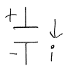 | 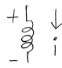
Energy |  | $$w=\frac{1}{2}Cv^{2}$$
Charge
Time Constant  $τ$ |  | $$τ=RC$$ | $$τ=\frac{L}{R}$$
Physical Properties
Components in series | $$R_{eqv}=R_{1}+R_{2}$$ | $$C_{eqv}=\frac{1}{\frac{1}{C_{1}}+\frac{1}{C_{2}}}$$ | $$L_{eqv}=L_{1}+L_{2}$$
Components in parallel | $$R_{eqv}=\frac{1}{\frac{1}{R_{1}}+\frac{1}{R_{2}}}$$ | $${C_{eqv}=C}_{1}+C_{2}$$ | $$L_{eqv}=\frac{1}{\frac{1}{L_{1}}+\frac{1}{L_{2}}}$$
Phasor | R | $$Z_{C}=\frac{1}{Jωt}$$ | $$Z_{L}=JωL$$

If $f\left(t\right)=ke^{st}$ then $\frac{d}{dt}f\left(t\right)=kse^{st}=sf(t)$. If $s<0$ then $f\left(0\right)=k and f\left(∞\right)=0.$
If $f\left(t\right)=k_{1}+k_{2}e^{st}$ then $\frac{d}{dt}f\left(t\right)=sf\left(t\right)-sk_{1}$. If $s<0$ then $f\left(0\right)=k_{1}+k_{2} and f\left(∞\right)=k_{1}.$

